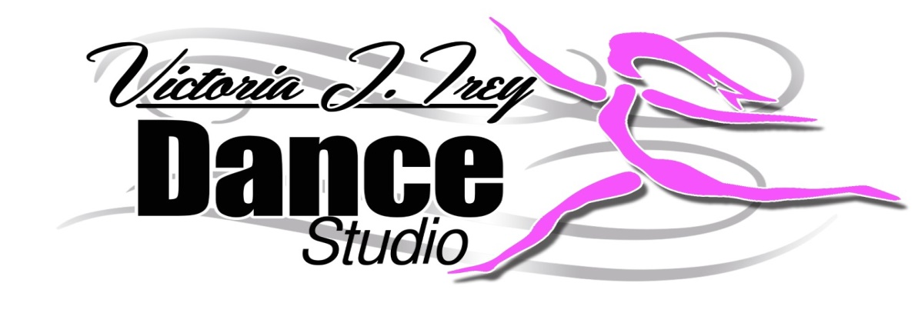

At the Victoria Irey Dance Studio we are following CDC guidelines for strict social distancing and cleaning protocols. As any other public place, we cannot guarantee that your child will not be exposed to COVID-19 or any other virus, (whether at Victoria Irey Dance studio or elsewhere) or if exposed, that your child will not contract the disease.

By signing below, you agree to waive any claims of liability against the Victoria Irey Dance Studio and to hold The Victoria Irey Dance Studio harmless if your child contracts COVID-19 despite our best efforts to prevent it.

Additionally, I agree to notify The Victoria Irey Dance Studio if my child or any member of your household contracts COVID-19 or has come into contact with someone who has tested positive for COVID-19. This action will help ensure the utmost safety of our dancers and staff.

Child’s Name (s)_______________________________________________________

Parents Printed Name_________________________________________________

Parents Signature______________________________________________________

Date_______________________________________

